Connecting Excel Sheet With SQL Server:

* Open Excel Sheet and save it with desired name
* Go to Data tab

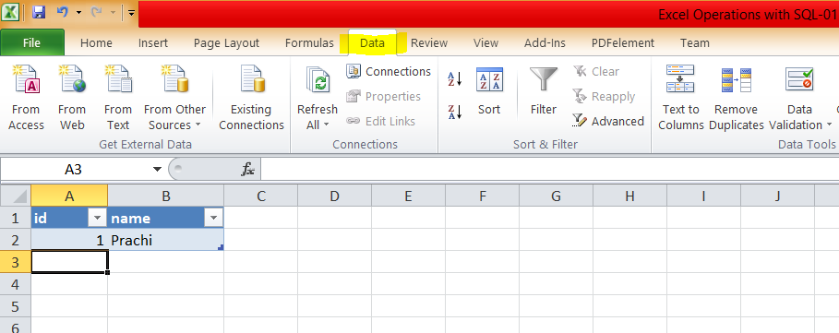

* Dropdown arrow ‘From Other Sources’ then ‘From Data Connection Wizard’

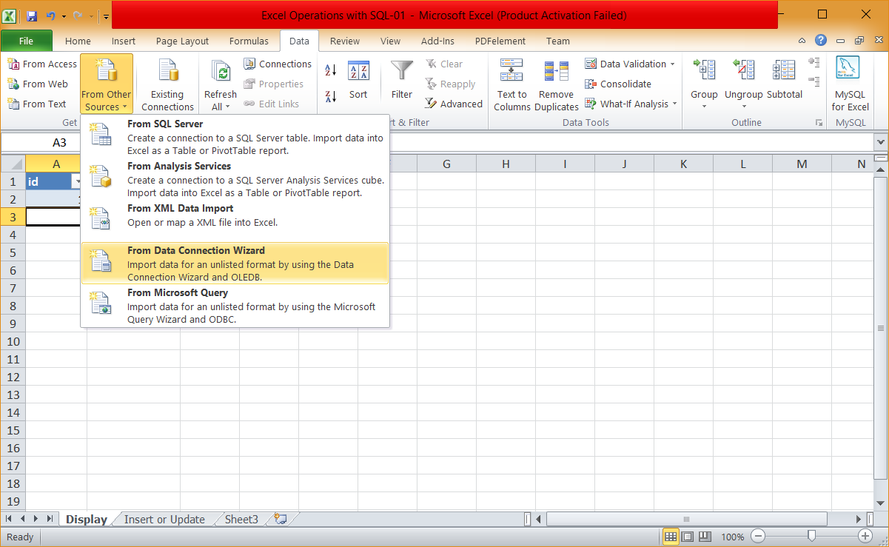

* You will see Data Connection Wizard. Select ‘Microsoft SQL Server’

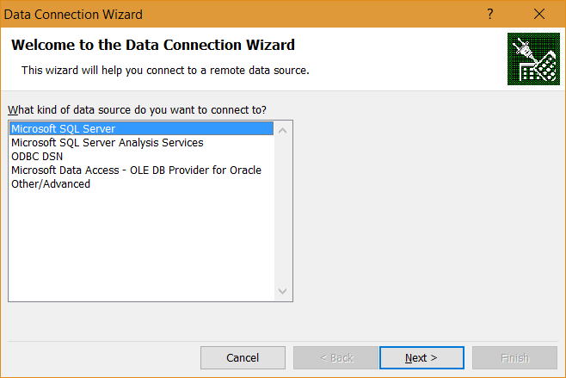

* Click next and then it will ask you for Server name. You can find it when you start SQL server management studio or you can type SQLCMD –L in command prompt to search it.

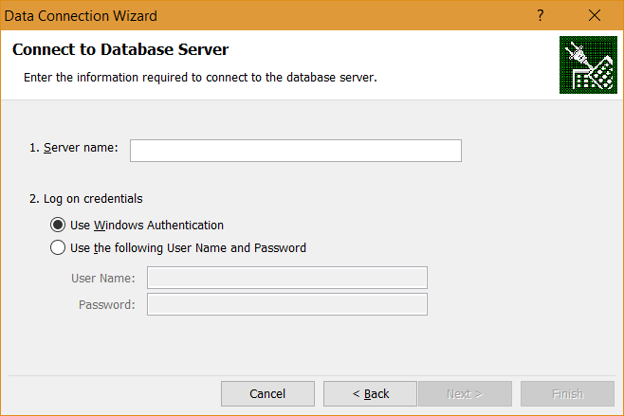

* Excel will ask you name of sql table to connect. Enter name and you are ready